CHAPTER – 7
OUTPUT SCREENSHOTS

This chapter presents the output screens of the GPAS Secure system. The screenshots demonstrate the working of different modules such as registration, login, graphical password selection, dashboard, file management, and admin panel. Each screenshot is explained to provide a clear understanding of system functionality.

7.1 User Registration Page
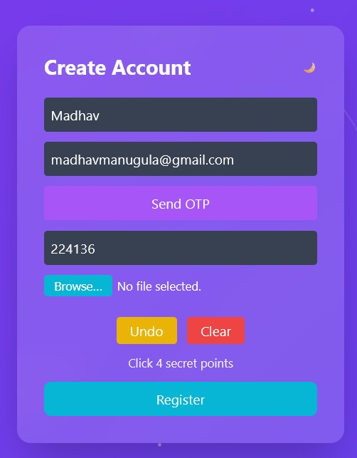
Fig 7.1: User Registration Page

The registration page allows new users to create an account by entering their username and email. After submitting the details, the system generates an OTP for verification before proceeding further.

7.2 OTP Verification Screen
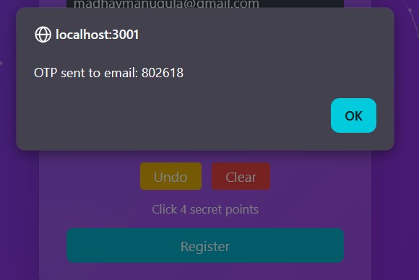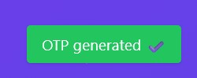
Fig 7.2: OTP Verification Screen

This screen displays the OTP verification process where the user enters the generated OTP. The system validates the OTP to ensure secure user registration.

7.3 Graphical Password Selection
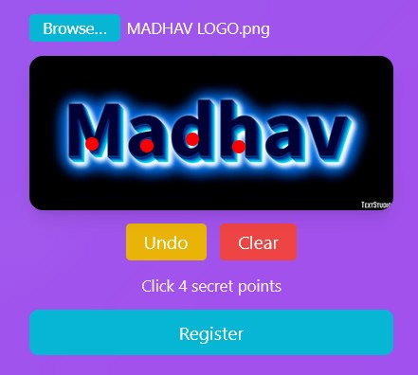
Fig 7.3: Graphical Password Selection

In this screen, the user selects specific points on an image to create a graphical password. These click points are stored securely in the database.

7.4 Login Page with Captcha
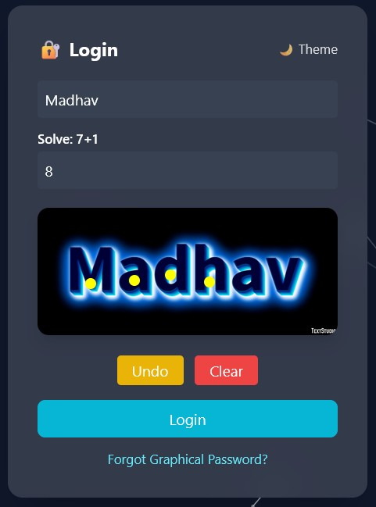
Fig 7.4: Login Page with Captcha

The login page requires the user to enter the username, solve a captcha, and select graphical password points to gain access to the system.

7.5 Successful Login Output
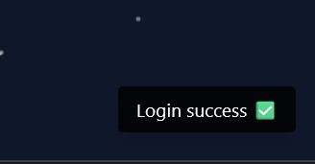
Fig 7.5: Successful Login Output

This screen shows the successful login message after correct authentication, granting access to the user dashboard.

7.6 Invalid Login Attempt Message
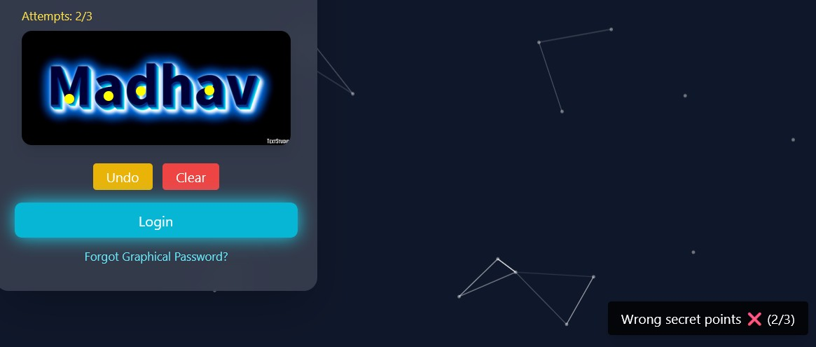Fig 7.6: Invalid Login Attempt Message

This screen displays an error message when incorrect credentials or graphical password points are entered.

7.7 Account Lock After 3 Attempts
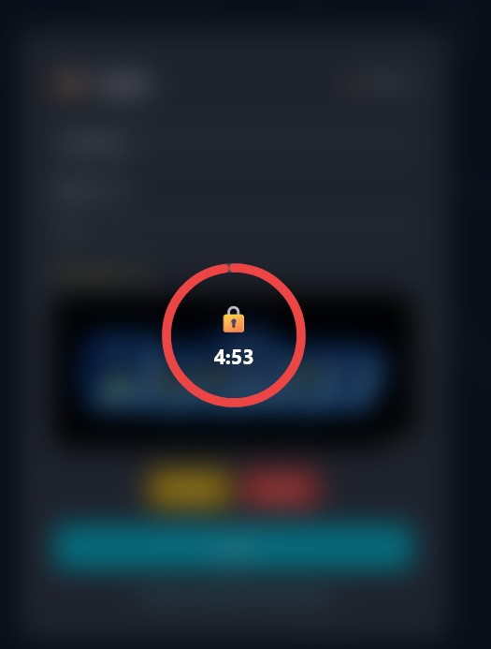
Fig 7.7: Account Lock After 3 Attempts

After three unsuccessful login attempts, the system temporarily locks the account.
7.8 User Dashboard
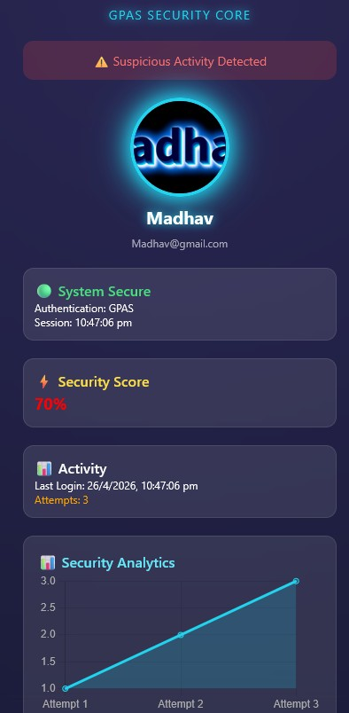
Fig 7.8: User Dashboard

The dashboard provides an overview of user activities, file management options, and security alerts.

7.9 File Upload System
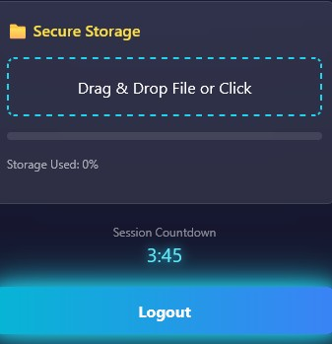
Fig 7.9: File Upload System

This screen allows users to upload files securely to the system.
7.10 File Preview / Download / Delete

Fig 7.10: File Management Options

This screen shows options to preview, download, and delete uploaded files.

7.11 Admin Dashboard
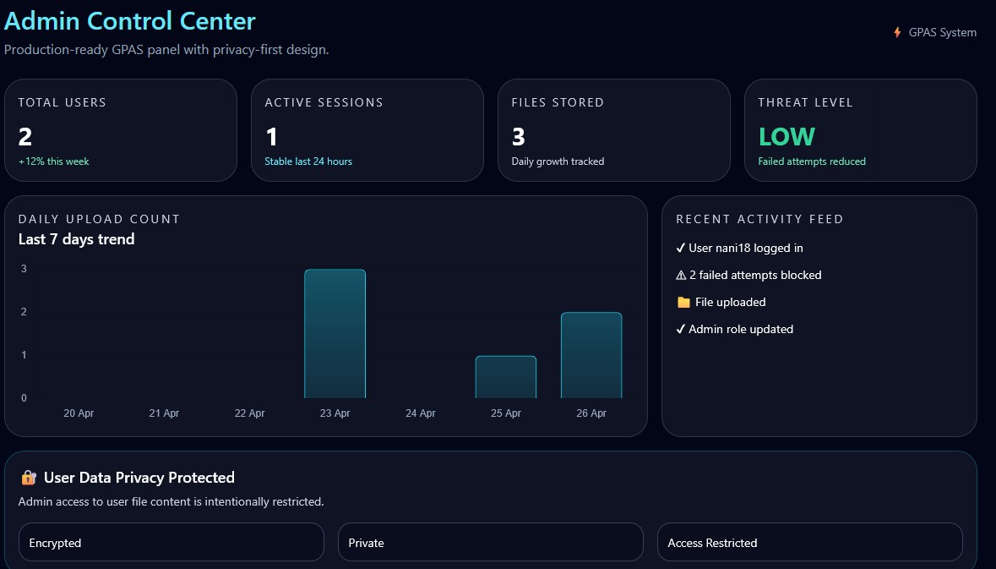
Fig 7.11: Admin Dashboard

The admin dashboard displays system statistics such as total users, activity logs, and system usage.
7.12 User Management Panel
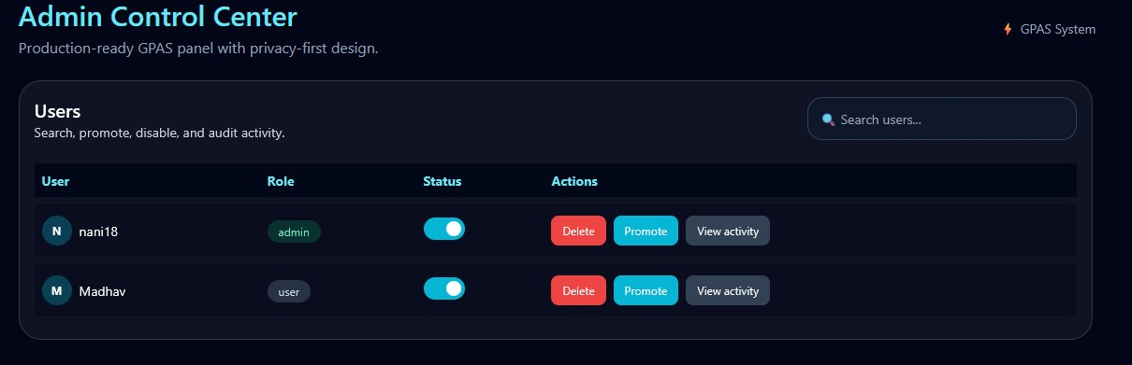
Fig 7.12: User Management Panel

This screen allows the admin to view, manage, and delete user accounts.

7.13 Activity Logs / Audit Logs
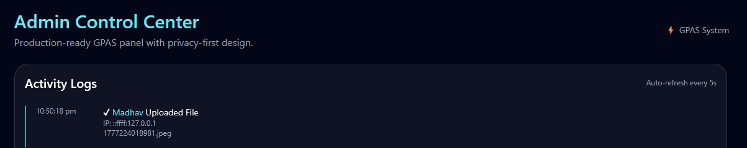
Fig 7.13: Activity Logs

This screen displays user activity logs for monitoring and security purposes.

7.14 Analytics Charts
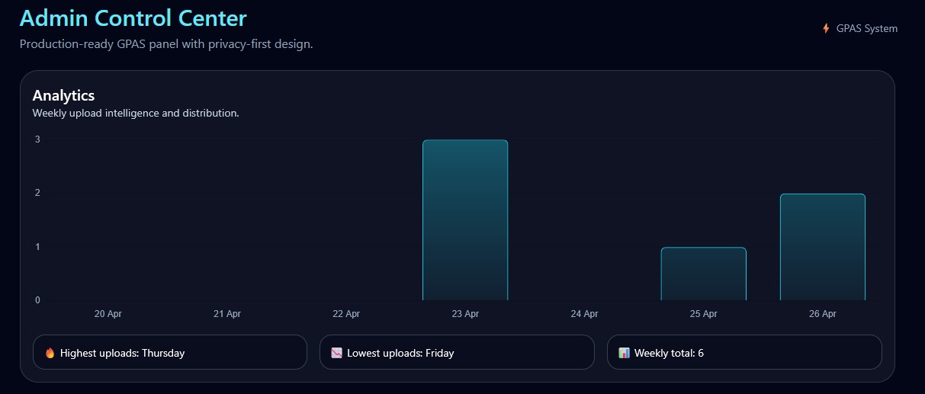
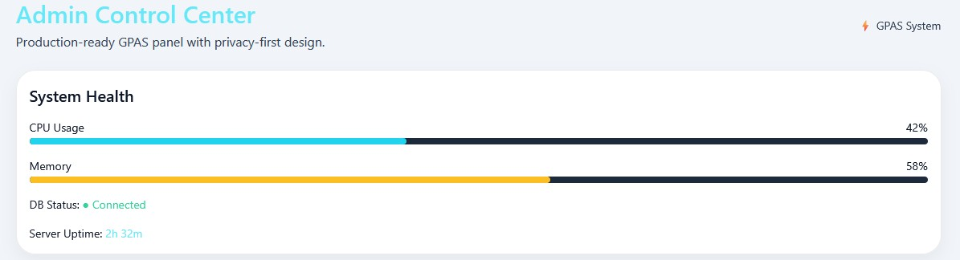
Fig 7.14: Analytics Charts

This screen presents graphical analysis of system health and activity statistics like (uploads).

7.15 Security Alerts
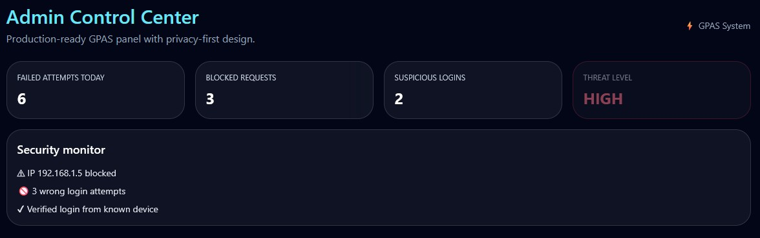
Fig 7.15: Security Alerts

This screen shows alerts related to suspicious activities and failed login attempts.

7.16 Logout / Session Timeout
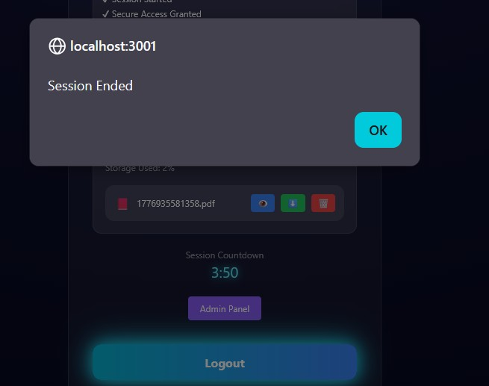
Fig 7.16: Logout Screen

This screen displays the logout or session timeout message for user security.

